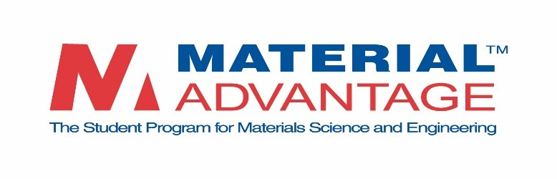

**MATERIAL ADVANTAGE UNDERGRADUATE STUDENT SPEAKING CONTEST**

**2024 Contestant Application**

Up to two students may participate from a single school.

For schools with Material Advantage Chapters, Material Advantage Faculty Advisors are asked to report the participant(s) based on a local chapter selection process.

*Students from schools without Material Advantage Chapters may apply directly, and the first two applicants from that school will be entered into the contest.*

|  |  |  |  |  |  |
| --- | --- | --- | --- | --- | --- |
| Name of School: | |  | | | |
| Name of student participant: | | |  | | |
| Email address of student participant: | | | |  | |
| Title of Talk: |  | | | | |
|  | | | | |  |

### The following equipment will be available to each student participant:

* Laptop computer
* Laser pointer/Presentation remote
* LCD projector/Screen
* Podium wireless microphone

*To be completed by schools with Material Advantage Chapters.*

|  |  |  |
| --- | --- | --- |
| Faculty Advisor: |  | |
| Faculty Advisor email address: | |  |

|  |  |
| --- | --- |
| Signed: |  |
| Date: |  |

Note: Return this form to Lori Houghton by **September 8, 2023**.  All entries must be received by this date to be eligible to participate in the national contest.